Lethbridge Art Prize Entry 2024 [Lethbridge Galley Padd]
Name of the Author: HOPE O’CHIN [Hope]
Title of the Art: View from the Boathouse Maroochy on Sunset [IMG_8752]
Medium: Acrylics on Canvas
Size: 1m 20cm Squared 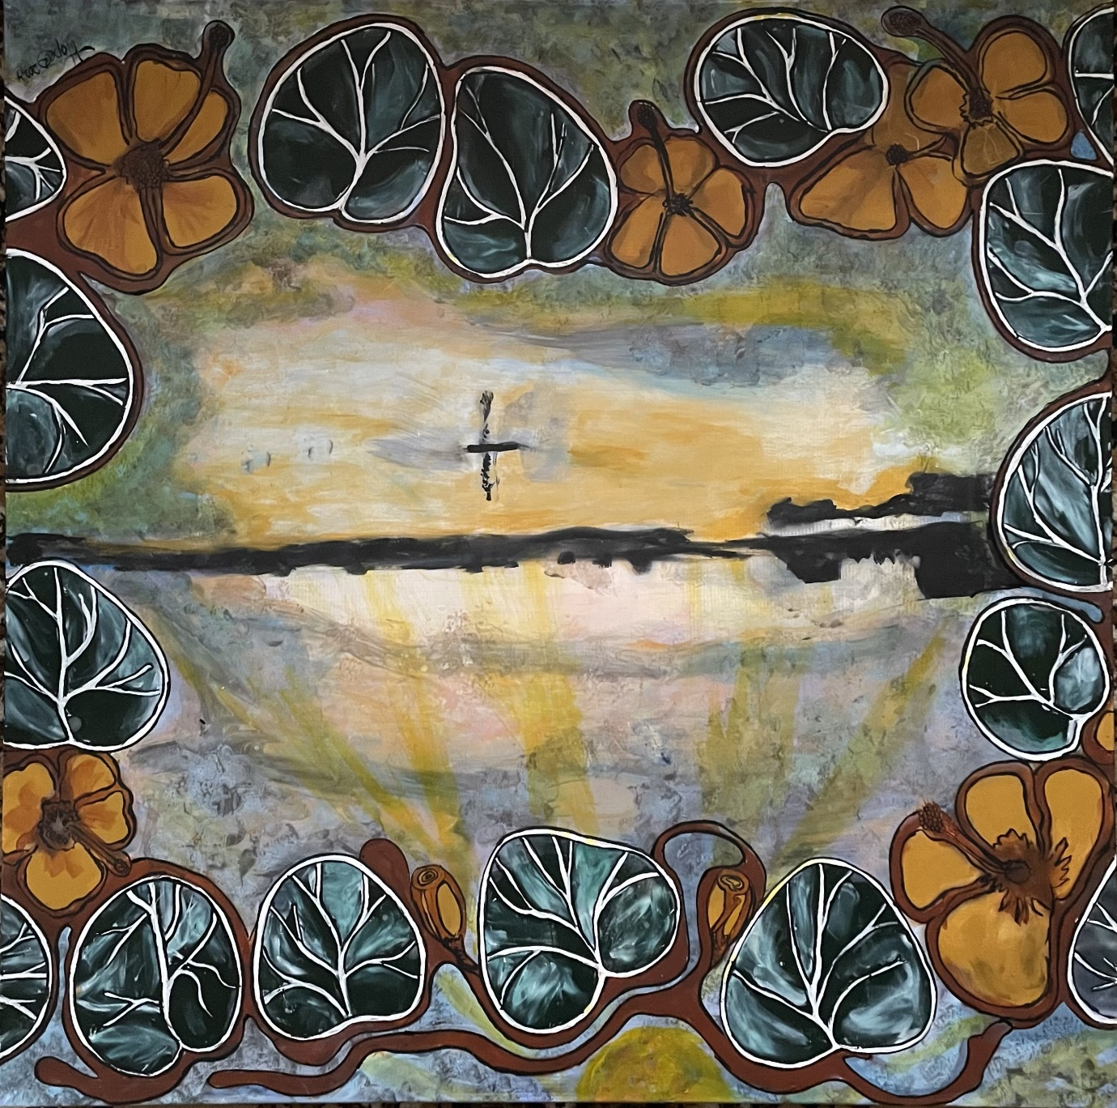

N.B. I tried to upload the photo however as the size may have been to large

50 WORD ARTIST STATEMENT
My art enabled me to contemplate my dreaming, my sense of place a place that my ancestors called their home. The lone paddle board rider hailed the changing of time. Knowingly I smiled, and closing my eyes I consciously relived being on country another time, and place, embracing my dreaming,

50 WORD ARTWORK STATEMENT
My art for this exhibition is an extension of a couple of other art pieces included in my last recent exhibition saltwater dreaming. Saltwater dreaming. Techniques for this art work incorporates elements of colour washes depicting the flow of the artist statement of dreaming and connectedness to place and time.
NAME OF PLACE Boathouse Coffee Shop at Cotton Tree on the Maroochy River

PAYMENT
PRICE
Pay via Credit Card

Pay via Direct Deposit

Bank Name: Westpac
Account Name: Lethbridge Gallery
BSB: 034 072
Account Number: 182 873
Your entry will be confirmed once bank deposit is received

